Media Day

August 16, 2014

**ALL** Players will take individual and team pictures. These will be available to purchase at OHS Fieldhouse. Bring Mark’s order form filled out with payment.

**Broncho Merchandise Available for Purchase at both events!**

Hamburgers for purchase at both events!

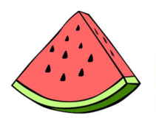**Watermelon Feed**

**August 21, 2014**

**7:00 P.M. @ Coleman Field**

**Come see our OHS Band, Showgirls, Wildbunch, Bronchettes, and Cheerleaders!!!**

